**Issue:** Unable to get Site Info from DBOR

**Resolution:**

1. If you are getting the below Error in USRP, Please inform to user follow the below Steps.

**Error Message:**

Reason: [getSiteInfoFromDBOR] : Unable to get Site Info from DBOR.

* Account setup is not properly completed in network.
* So please have the Network set up completed by contacting Network team after which this order can be resent through USRP.

Example Screenshot:

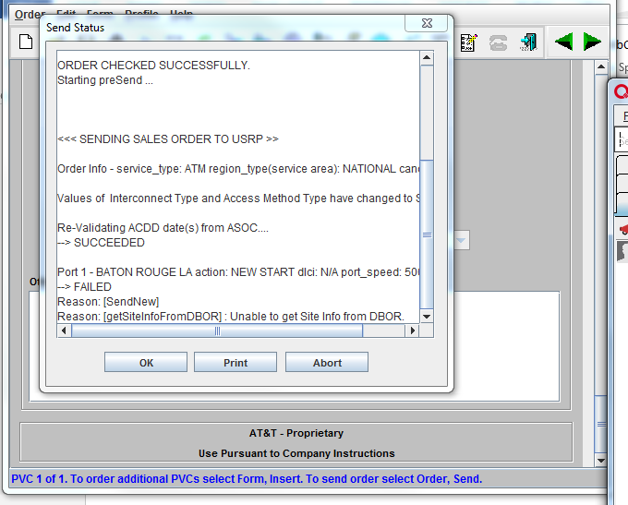

**Reference Tickets :** 228830799,228562418,228704756,229063797